Iñigo Gonzalez Portela
ingonzal@student.42urduliz.com

Caso Práctico 2: Redes y Computación en AWS
Tarea 1:
- VPC:
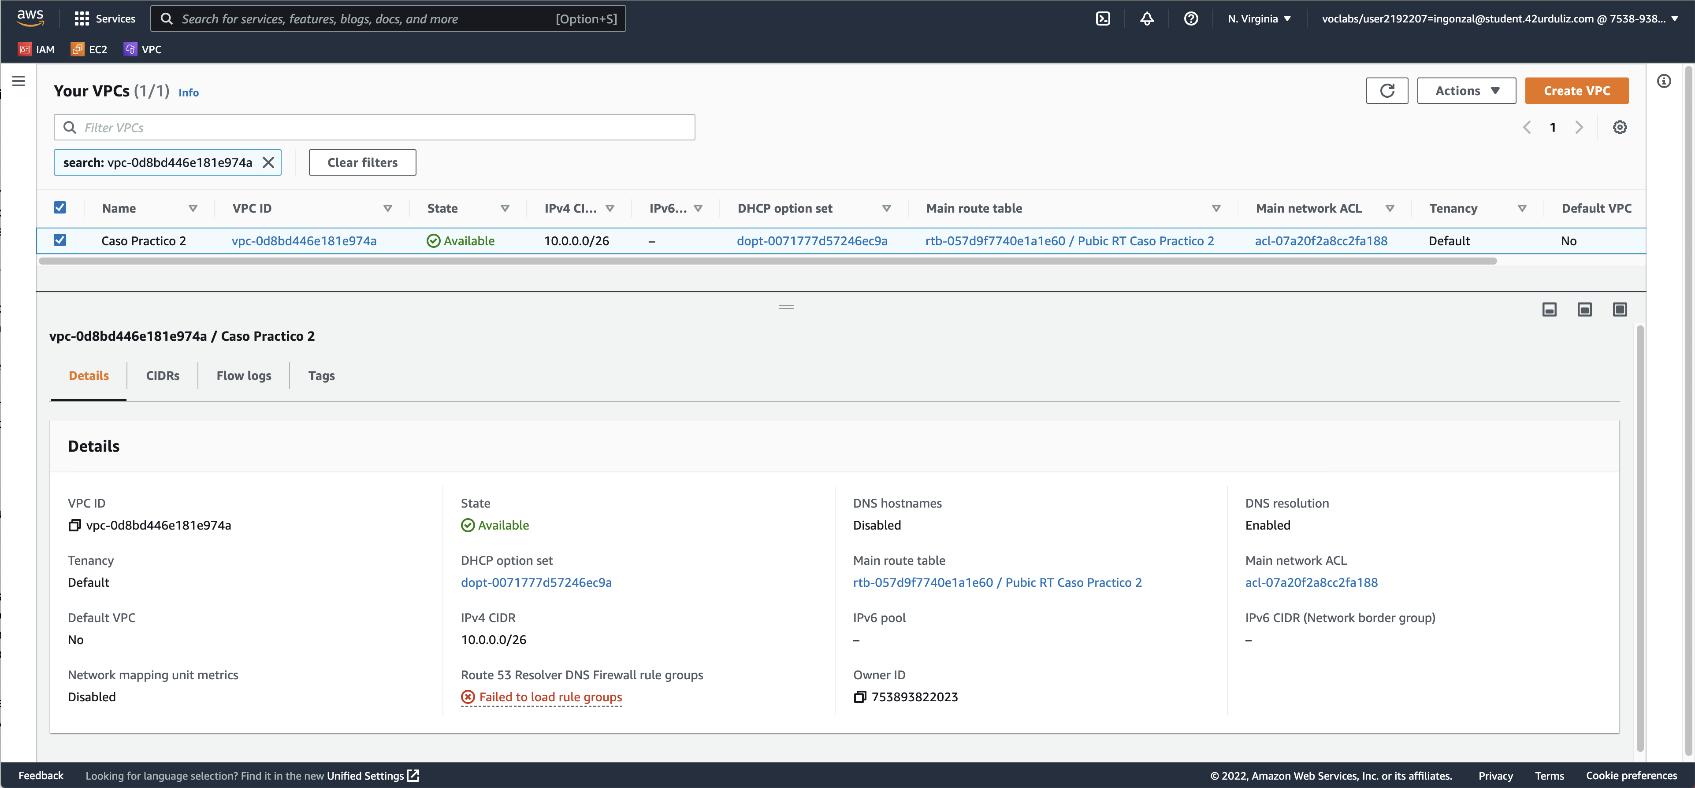
- Public Subnet:
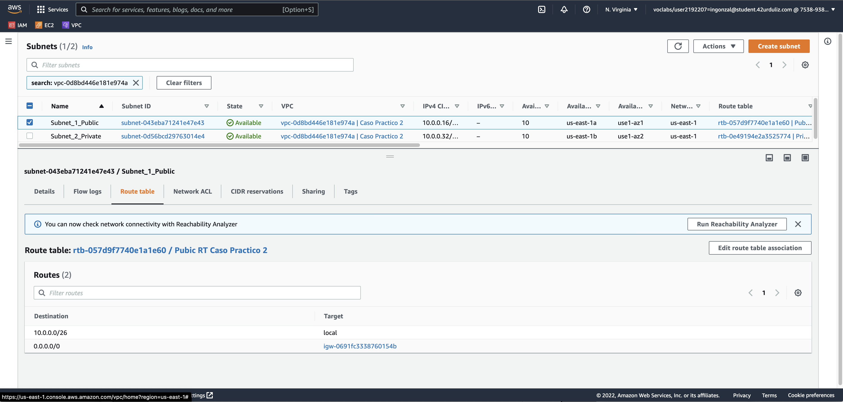
- Auto Assign Ipv4:
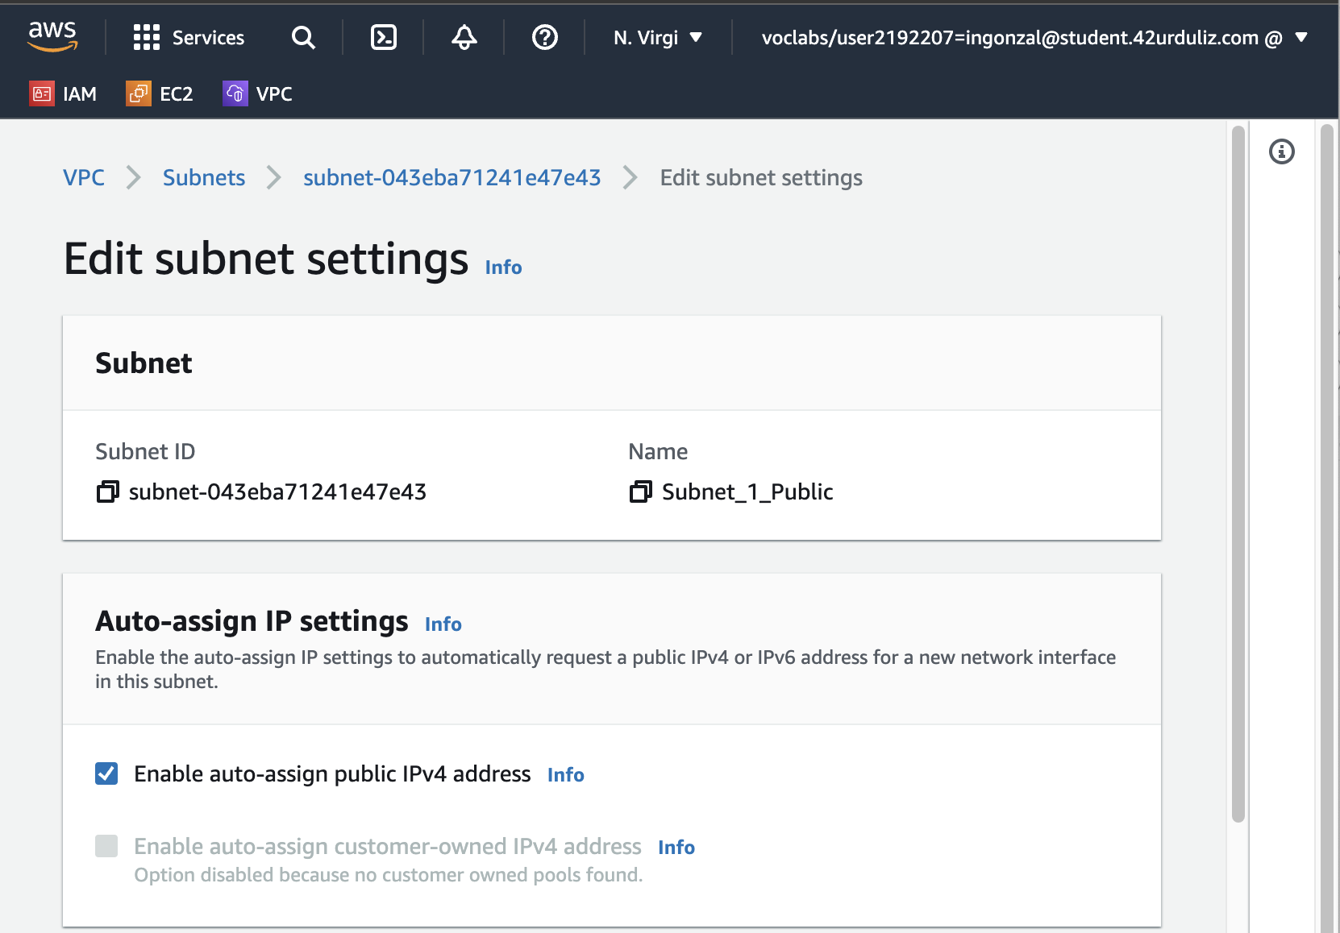
- Private Subnet:
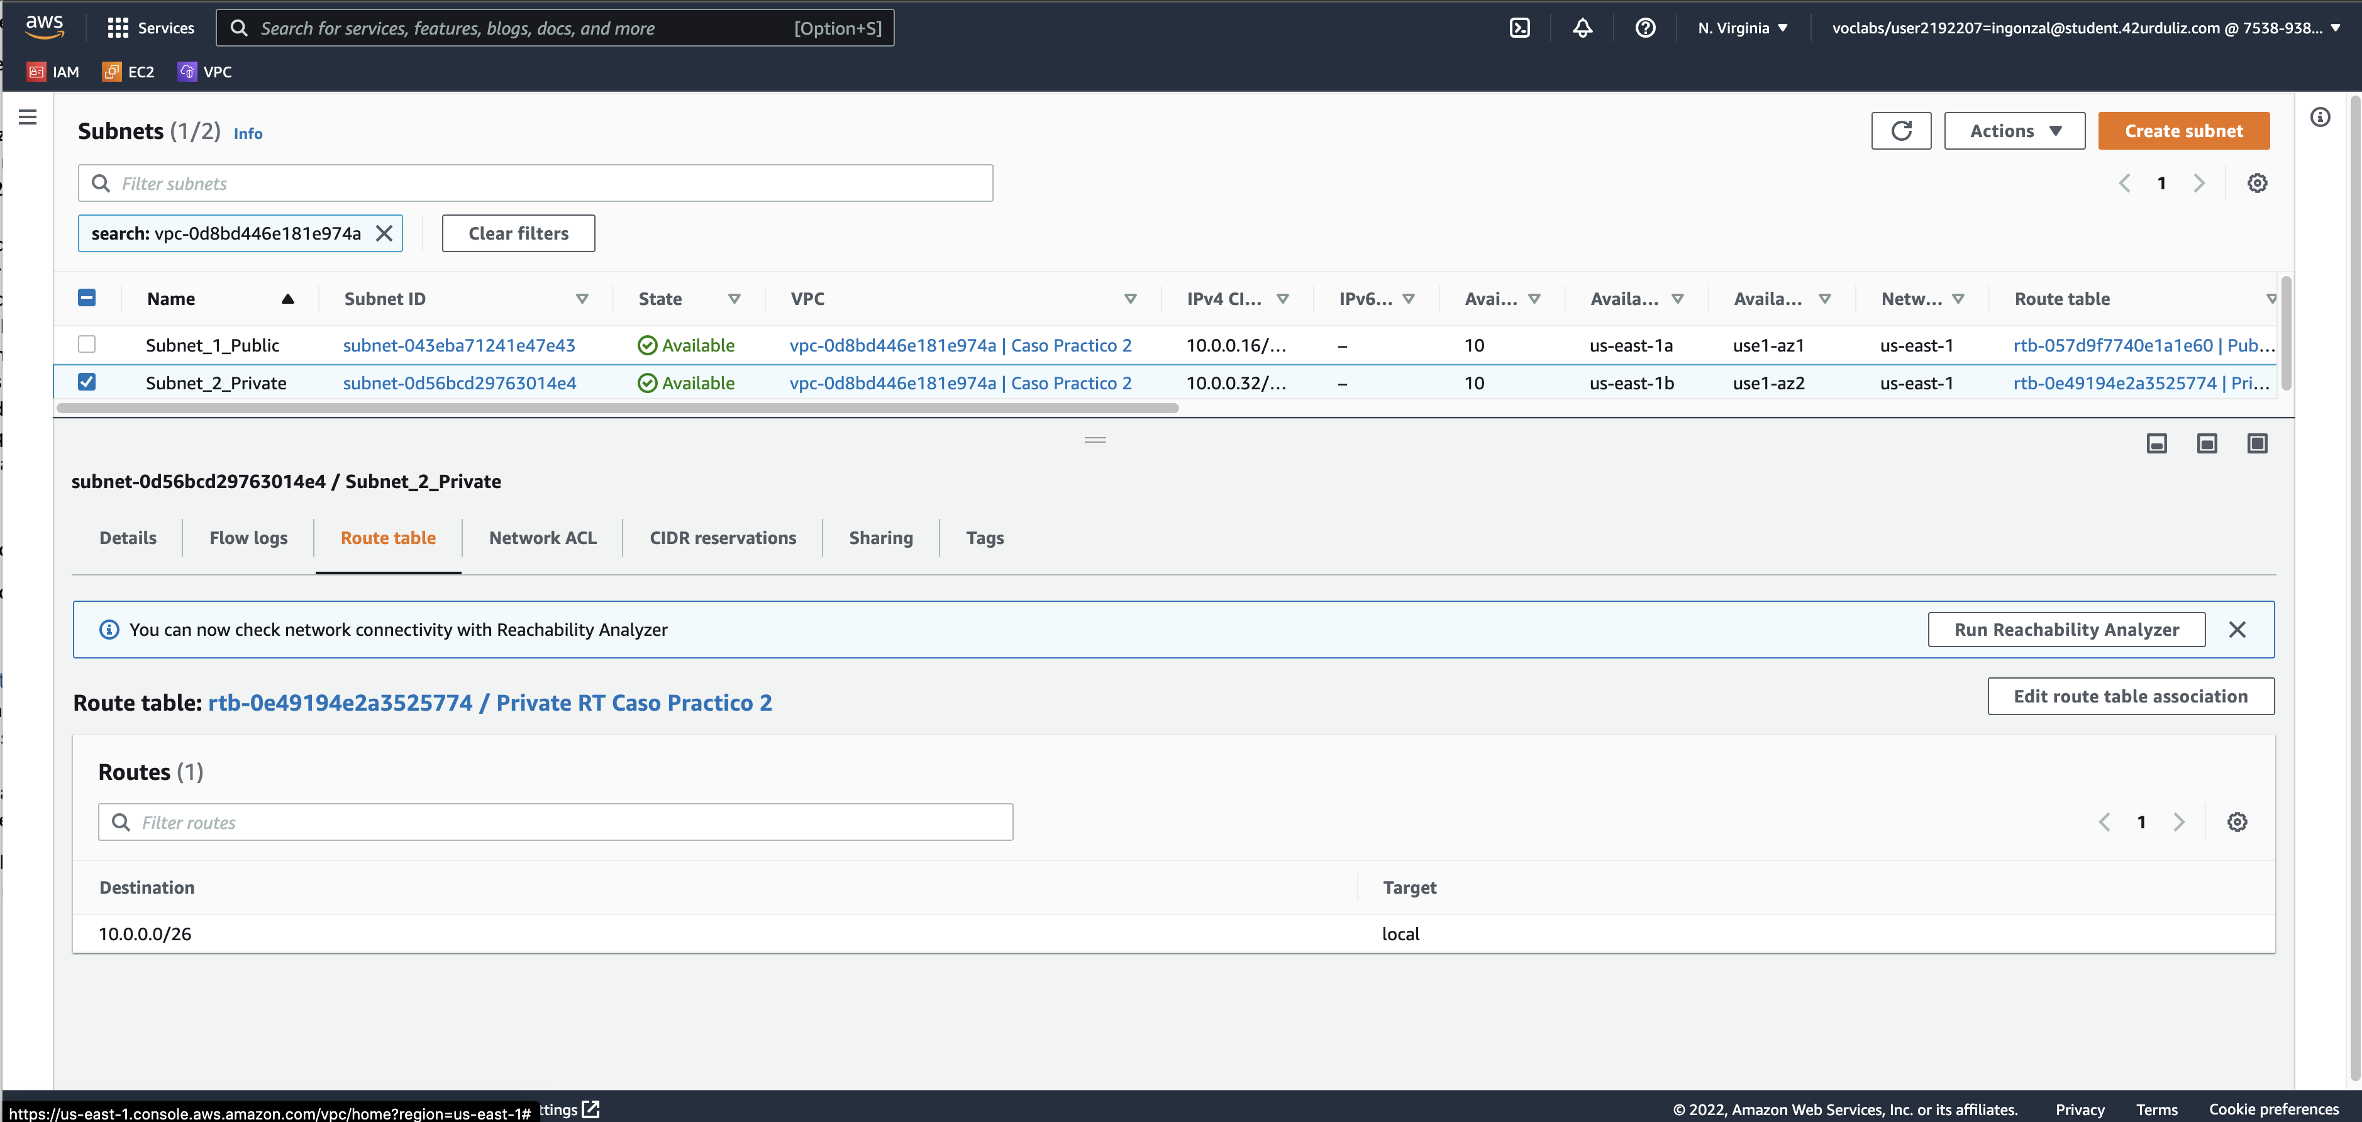
- Internet Gateway:
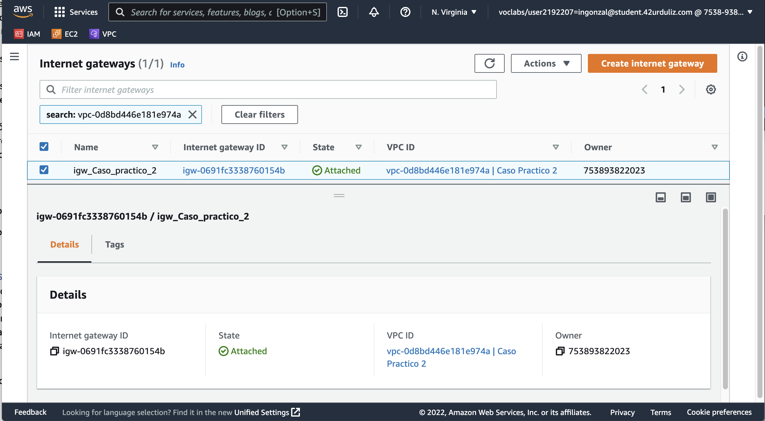

Tarea 2:
- EC2 script
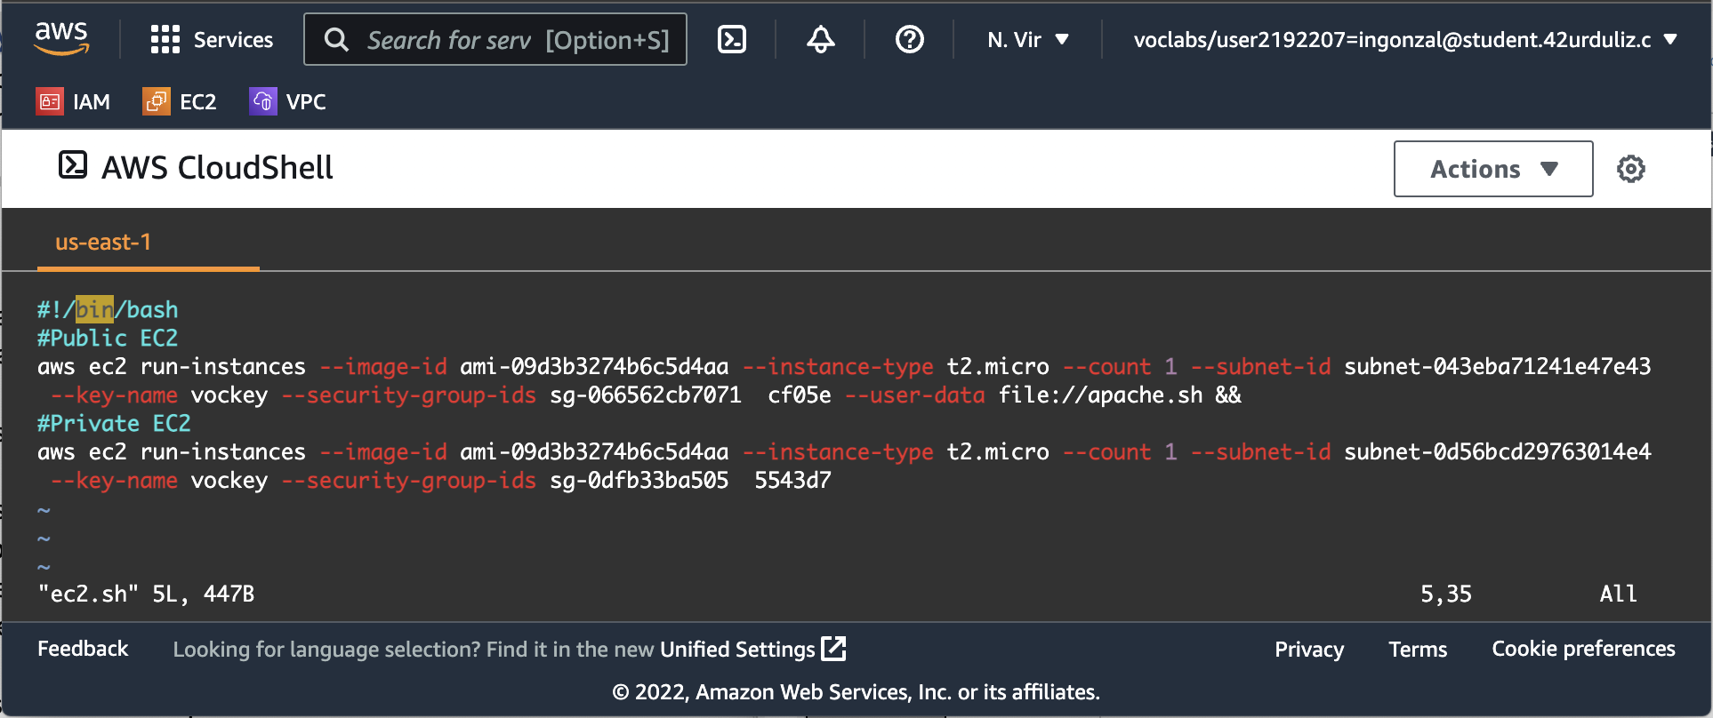
- Transcript:
#!/bin/bash
#Public EC2
aws ec2 run-instances --image-id ami-09d3b3274b6c5d4aa --instance-type t2.micro --count 1 --subnet-id subnet-043eba71241e47e43 --key-name vockey --security-group-ids sg-066562cb7071 cf05e --user-data file://apache.sh &&
#Private EC2
aws ec2 run-instances --image-id ami-09d3b3274b6c5d4aa --instance-type t2.micro --count 1 --subnet-id subnet-0d56bcd29763014e4 --key-name vockey --security-group-ids sg-0dfb33ba505 5543d7

Public Security Groups:
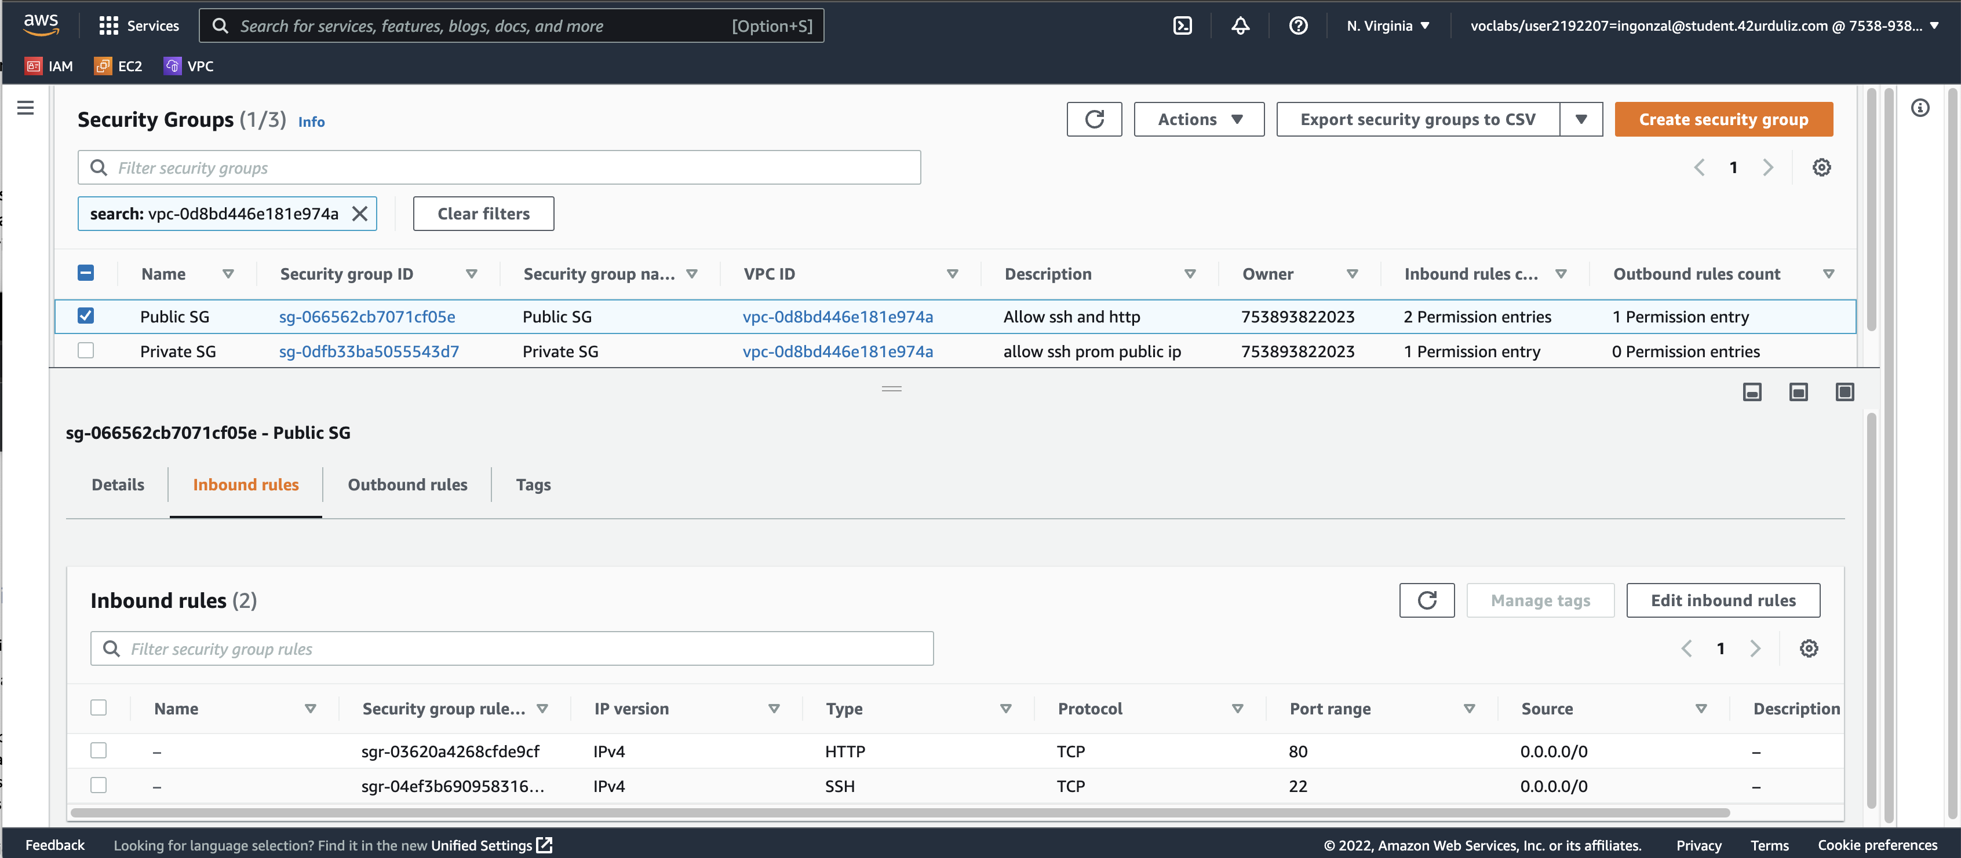
- Private Security Groups:
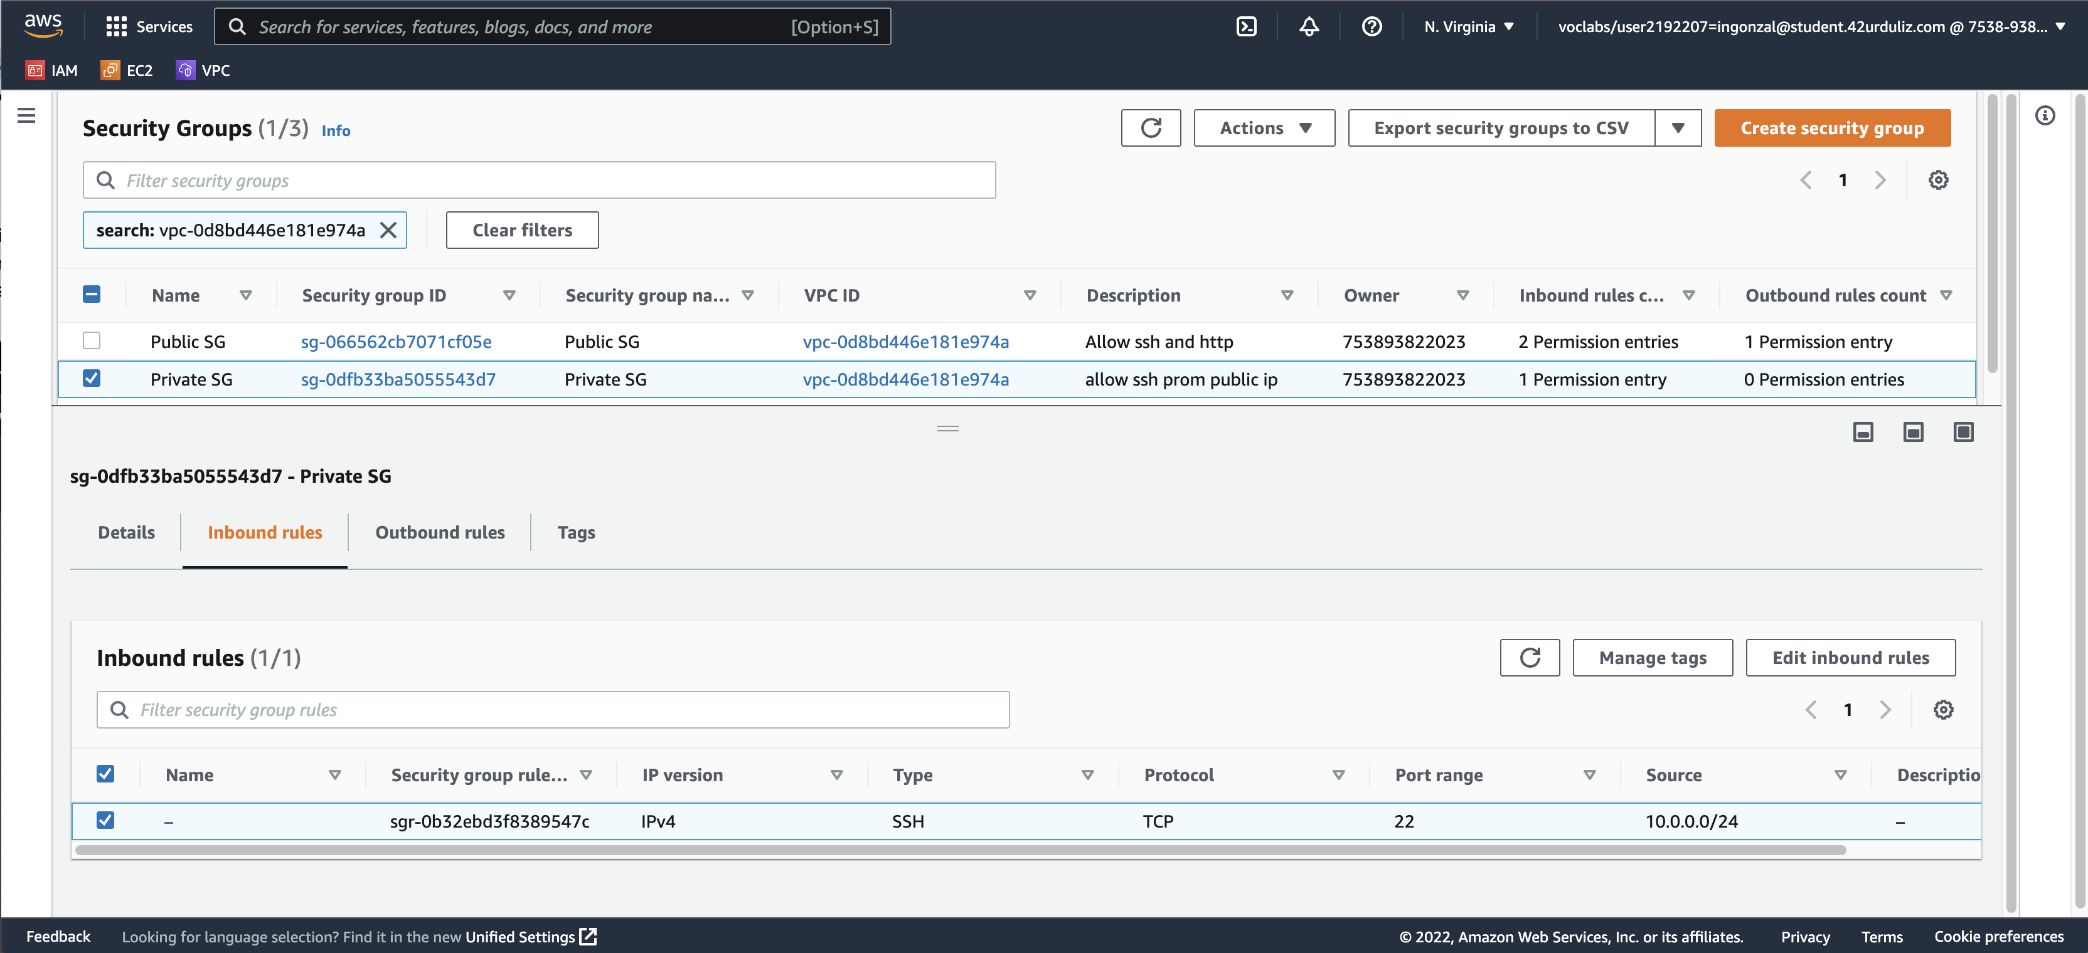
- User data Script:
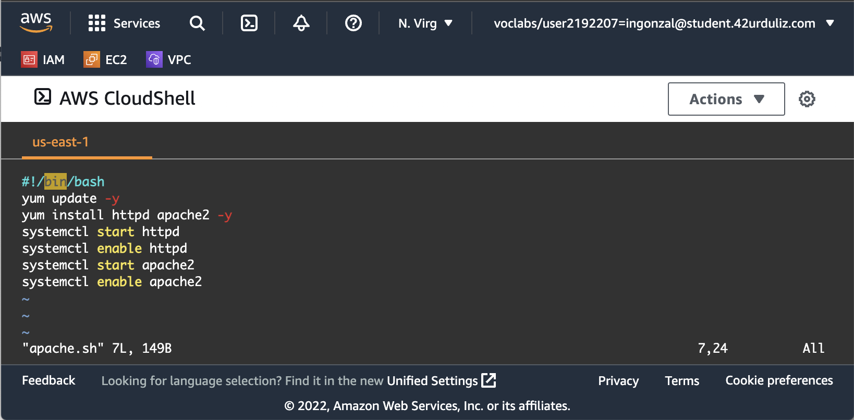
- Transcript:
#!/bin/bash
yum update -y
yum install httpd apache2 -y
systemctl start httpd
systemctl enable httpd
systemctl start apache2
systemctl enable apache2

- Comprobación apache

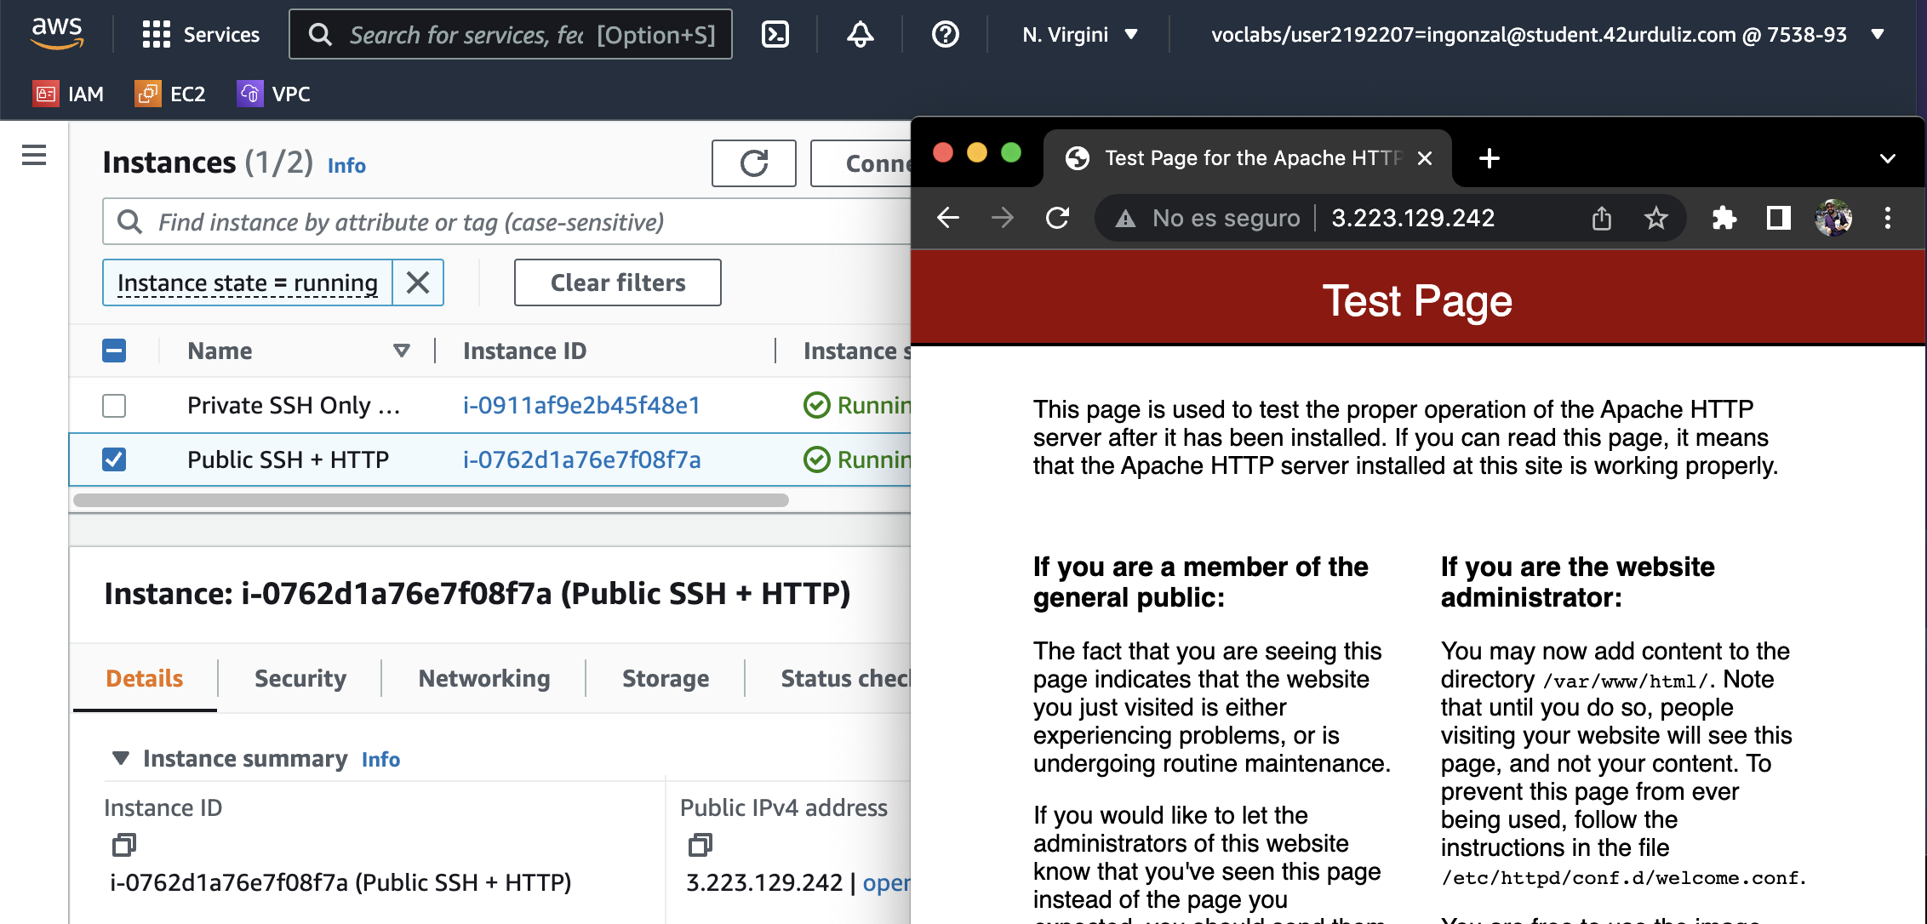

- Comprobación SSH a EC2 publica y privada



